DOCUMENTATION

TENSORFLOW

Shuhaib | Tensorflow practical test | 28/06/2024

# ACTIVITY – 1

## aim:

Create a 3*3 matrix of ones and a 3*3 matric of zero. Add them together using TensorFlow.

## requirements:

* Pc
* Jupyter lab/ vs code

## procedure/code:

* Step-1



* Step-2

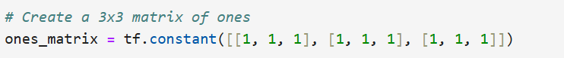

* Step-3

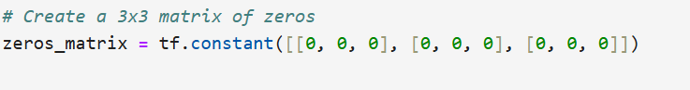

* Step-4

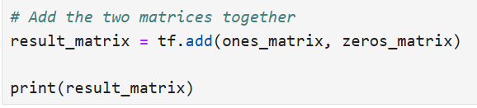

## OUTPUT:

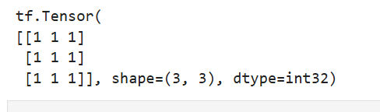

## RESULT:

The resulting matrix is printed, showing a 3x3 matrix filled with ones.

# ACTIVITY – 2

## aim:

implement a custom layer in tensorflow that performs a specific operations (eg.customactivation, function) use this layer as a simple model.

## requirements:

* Pc
* jupyternotebook / vs code
* TensorFlow library

## procedure/code:

* Step-1

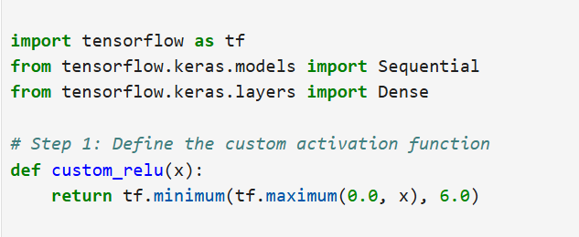

* Step-2

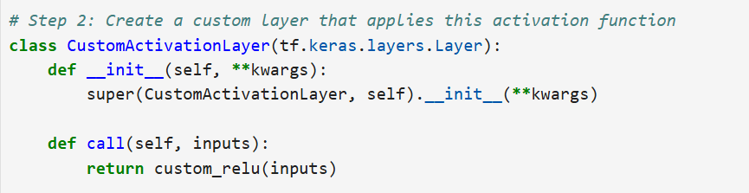

* Step-3

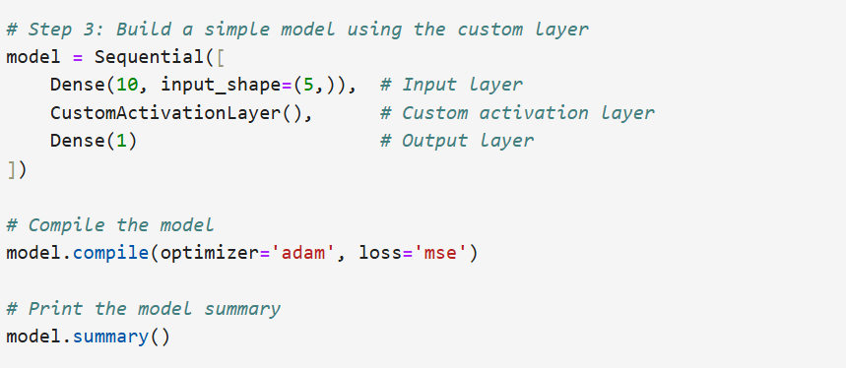

* Step-4

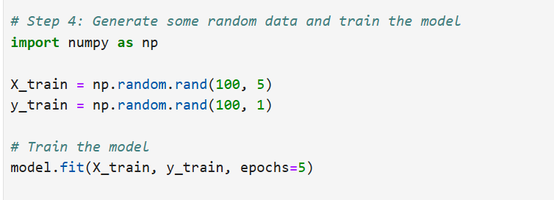

## OUTPUT:

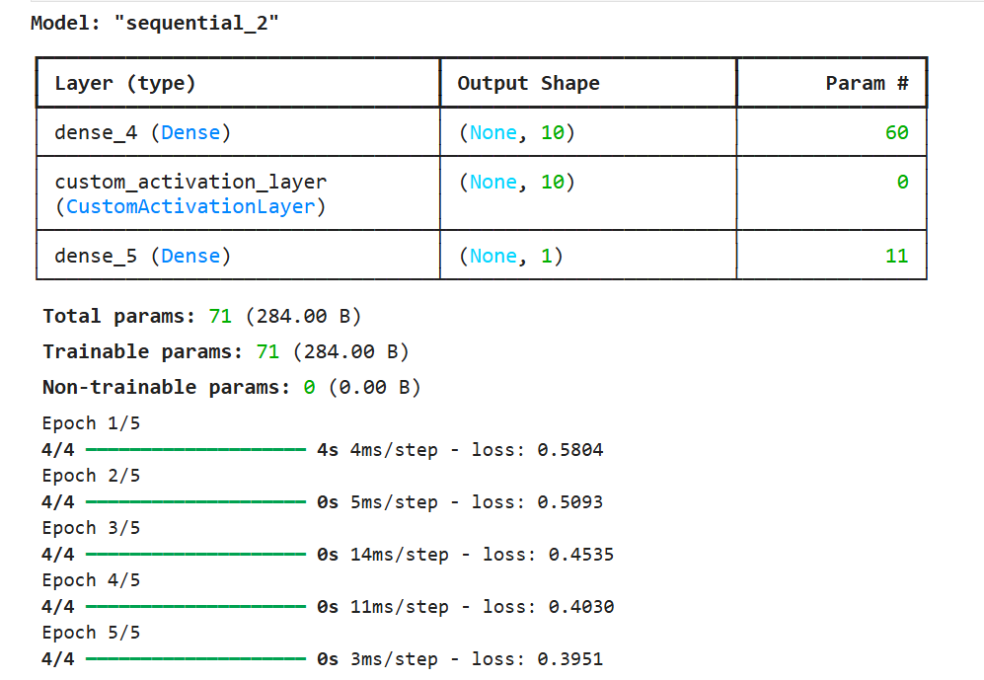

## RESULT:

Successfully executed program and displayed the output.

# ACTIVITY – 3

## aim:

## implement a simple example of distributed training using tf.distribute strategy to train a model on multiple GPUs

## requirements:

*     Pc

*     jupyternotebook / vs code

*     TensorFlow library

## procedure/code:

* Step-1

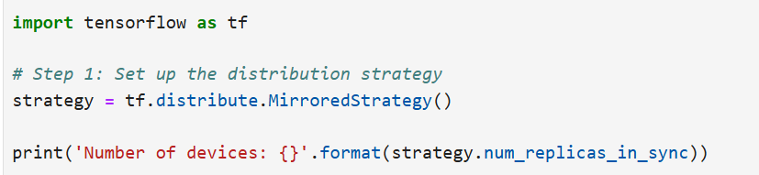

* Step-2

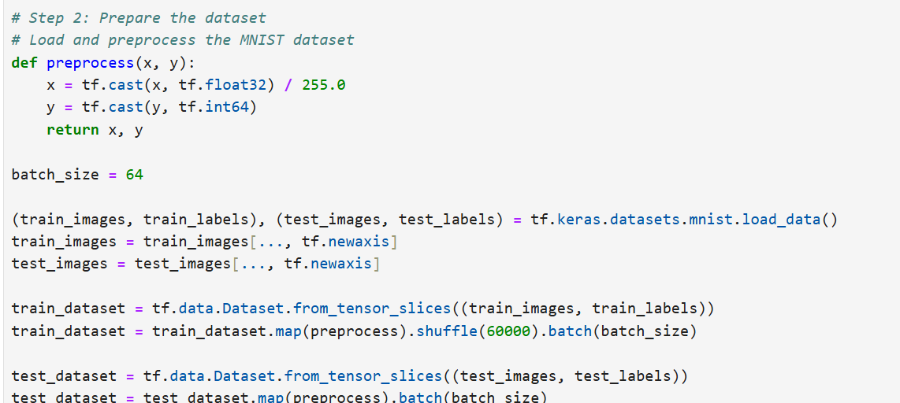

* Step-3

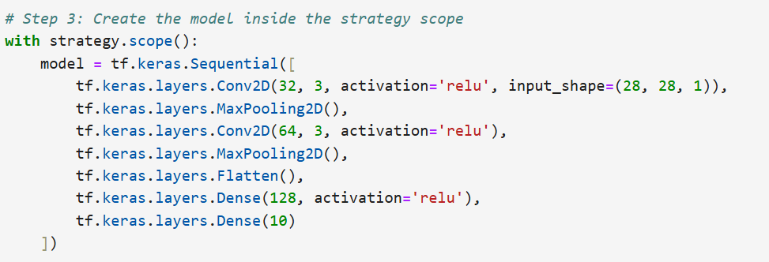

* Step-4

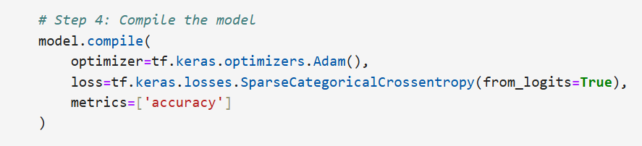

* Step-5



* Step-6

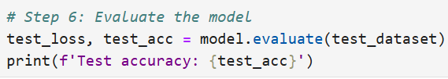

## OUTPUT:

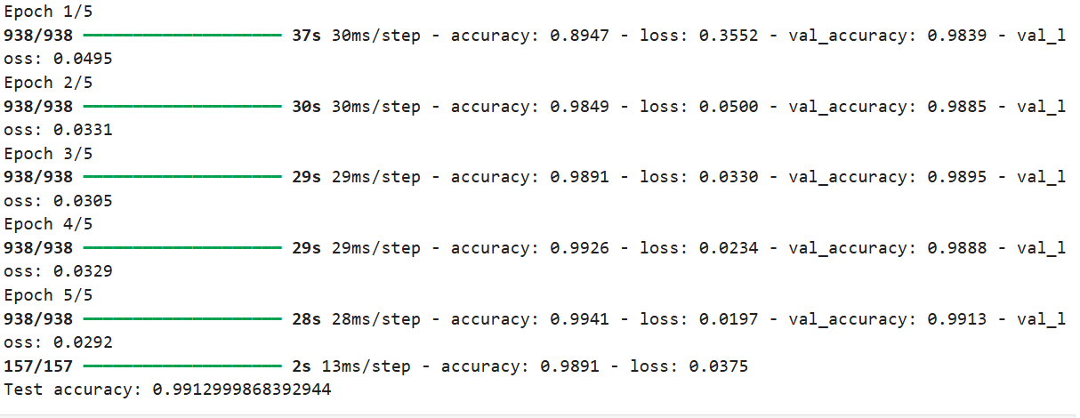



## RESULT:

Program executed successfully and display the output

# ACTIVITY – 4

## aim:

Write a TensorFlow function to calculate precision, recall, and F1-score for a multi-class classification problem

## requirements:

* Pc
* jupyternotebook/ vs code
* TensorFlow library

## procedure/code:

* Step-1

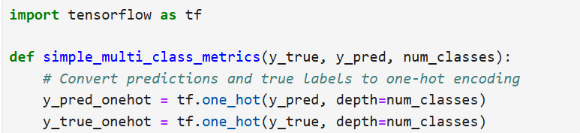

* Step-2

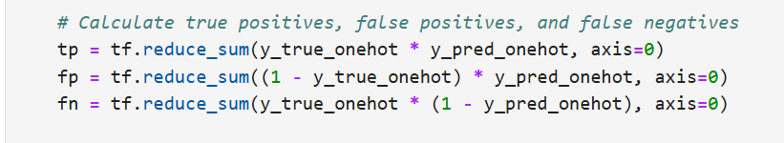

* Step-3

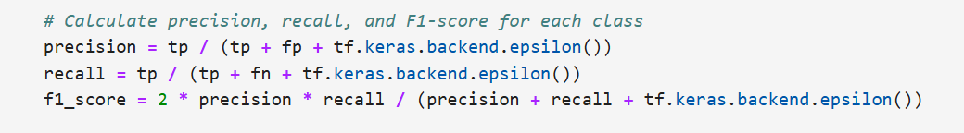

* Step-4

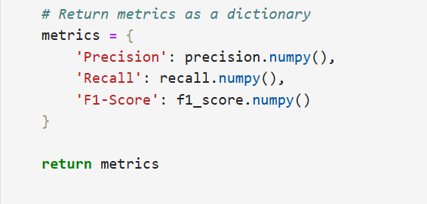

* Step-5

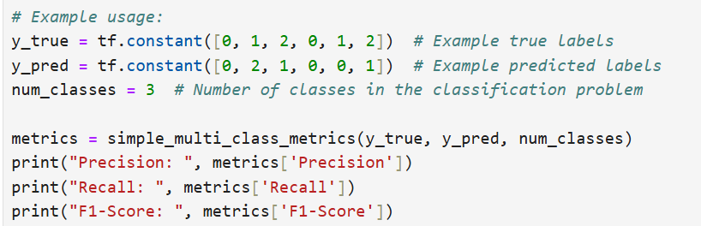

## OUTPUT:

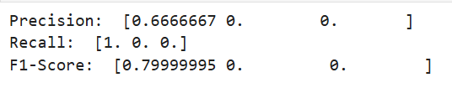

## RESULT:

Program executed successfully and displayed the output.